Ziya Gökalp Mah. İkitelli Organize Sanayi Bölgesi Atatürk Bulvarı No:50 34490 Başakşehir / İstanbul / TÜRKİYE
Telefon : +90 212 549 22 52
Faks : +90 212 549 25 80
Web : www.emasas.com.tr


EMAS ELEKTROTEKNİK MAKİNA SANAYİ VE TİCARET A.Ş

Technical Specifications : P2AB

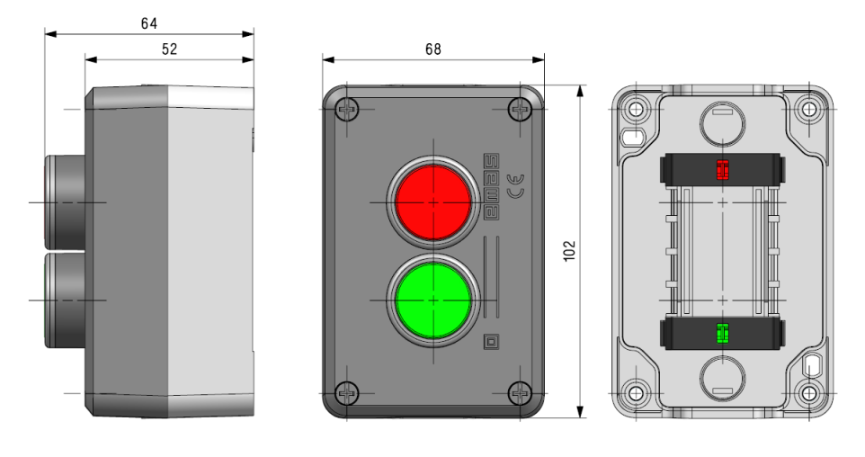

Technical Information :

Notes:Technical specifications of the contact block mounted in the control boxes
Body:
Plastic Body.
Opportunity of positioning with plates and Badge Bases.
General Specifications
Operating Temparature | -5/+40°C
Mechanical life | 0,5 Million (3000 open-close/hour
Electrical Life | 0,1 Million (1800 open-close/hour)
C.Block Tightening Torque | 0,6-0,8 Nm
C.Block Connection Wire Profile | Min: 1x0,5 mm'2
Wire Profile | Max: 2x2,5 mm'2
Protection Degree | IP50

Standards:

- TS EN 60947 -5-1

In contact Blocks;

- VDE 0660
- UL 508





General Specifications
Range Of Use |  | AC15
Operating Voltage | Ue | 250V AC
Fregquency | f | 50Hz
Operating Current | Ie | 4A
Insulation Resistance | Ui | 300V
Stroke Resistance Voltage | Uimp | 2.5kV
Dielectrical Strength |  | 1500V AC
Electrical Informations :

