Ziya Gökalp Mah. İkitelli Organize Sanayi Bölgesi Atatürk Bulvarı No:50 34490 Başakşehir / İstanbul / TÜRKİYE
Telefon : +90 212 549 22 52
Faks : +90 212 549 25 80
Web : www.emasas.com.tr


EMAS ELEKTROTEKNİK MAKİNA SANAYİ VE TİCARET A.Ş

Technical Spesification:EBM06PD12

Order Code:
EBM06PD12

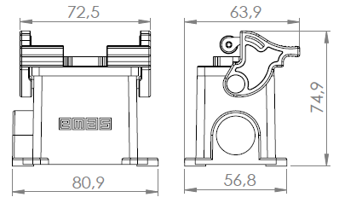

Number of Contacts:

6P+E

Technical Information:

Body :
-Easy assembly with fixed-not falling screw

General Specificaitons
Operating Temprature | -40/+125°C
Mechnical Life | ≥500 120 (op/hour)
Electirical Life | ≥100 240 (op/hour)
Cable Tightening Torque | 1,2-1,5 Nm
Wire Profile | 2,5 mm²

Genel Özellikler
Range of use |  | AC15
Operating Voltage | Ue | 400V AC
Insulation Voltage | Ui | 690V
Frequency | f | 50Hz
Operating Current | Ie | 16A
Stroke resistance voltage | Uimp | 6kV
Short circuit breaking capacity | Icn | 1kA
Insulation Resistance |  | 10 MΩ min
Dielectric Strength (For 1 min.) |  | 3000V

Electrical Information:
Standards:

- TS EN 61984



 (contacts)

Electrical Informations :
General Specifications
Range Of Use |  | AC15
Operating Voltage | Ue | 230V AC
Fregquency | F | 50Hz
Operating Current | Ie | 4A
Insulation Resistance | Ui | 300V
Stroke Resistance Voltage | Uimp | 2.5kV
Dielectrical Strength |  | 1500V AC

